A000-Afr-D R Congo-Songye-Divination board-Late 19th c

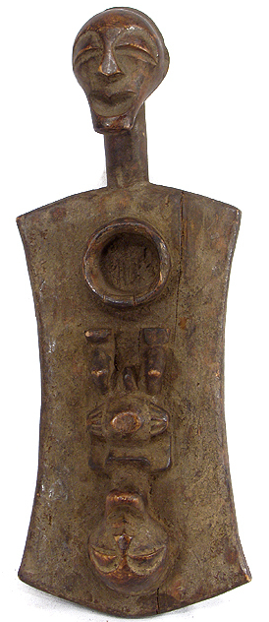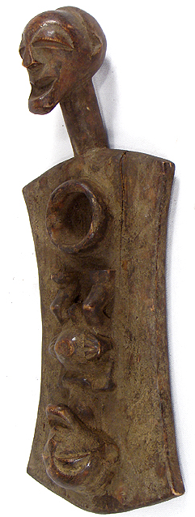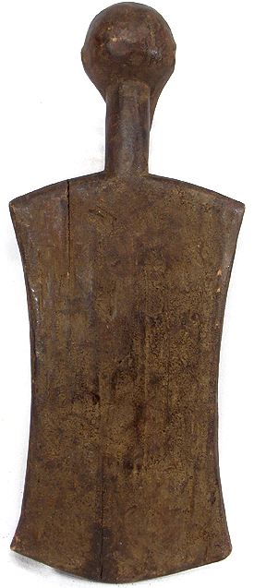

Figs. 1-3. Afr-D R Congo-Songye-Divination board-Late 19th c

**Case. No.: 6**

**Accession No.**

**Formal Label:** Afr-D R Congo-Songye-Divination board-Late 19th c

**Display Description:**

Songye Figural Divination Board African RARE

A wooden board supported with a carved human head. A carved figure laid on the board as well as a bowl. The  head and the figure on this  board  reflect the style of the Songye artistry tradition.  This is a  rare Songye figural board available on the market. Luba divination boards, especially the so- called LUKASA are the most famous boards that hold and record important part of historical information and genealogies regarding the Luba history. In the case of a Lukasa, each element on the board is a symbol of an event or a message. Reading and interpreting these signs belong to the skilled person such as the mediums the diviners, members of the Mbudye secret society, and local historians who can also read the other world.

This board does not include the symbolic elements seen on many Lukasa. Therefore, it may be considered as a divination board used as a mat or support for other divination device such as the Katatola, which is a small sculpture that would be held by the diviner and the patient who would rub it on the board such as this or possibly on a mat or even on the ground. The diviner would ask questions and the small moving sculpture would provide answers through its movements and the conversation between the diviner and the spirits of ancestors, between the diviner and  his/or her patient.

**Accession Number:**

**LC Classification:**

**Date or Time Horizon: late 19th c**

**Geographical Area:**

**Map:**

**GPS coordinates:**

**Cultural Affiliation:**

**Media: wood, pigment**

**Dimensions:** 14.75 inches H. x 6 inches W.

**Weight:**

**Condition:** Small splits, scrapes and cracks are a normal part of their patina attesting to their age and extensive use.

**Provenance:** I have examined this piece and agree with the description

Niangi Batulukisi, PhD.

**Discussion:**

Songye as well as Luba people share a number of different forms of divination used to determine the causes of misfortune or illness or family difficulties or simply the bad side of human experiences.

Some of the greatest examples of their art serve specific roles in divination. Divination boards like this play a substantial role.

**References:**

Mary Nooter Roberts and Allen F. Roberts, 1996, LUBA ART AND THE MAKING OF HISTORY, Prestel, Museum for African Art, New York;

Dunja Hersak,Songye Masks and sculpture figures, 1985